Lesson Plan: Silk Road and Globalization
A Teacher’s Resource Guide
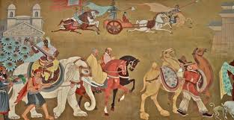
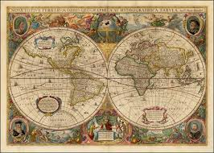
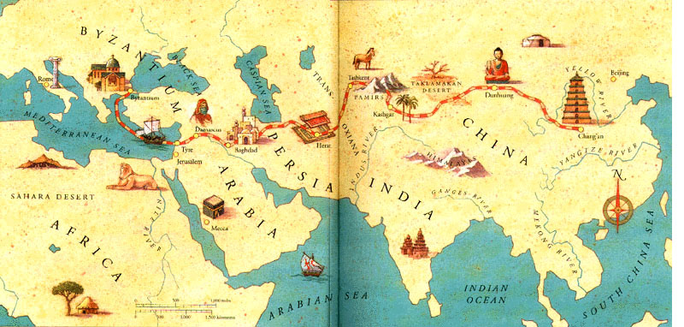

Researched and Developed By Shruthi Shree Nagarajan,
NRC Curriculum Developer

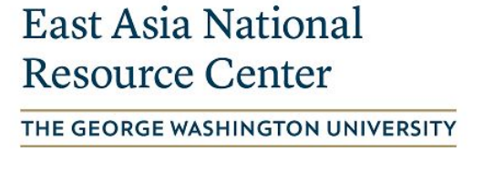

Lesson Plan: Silk Road and Globalization

Subject: World History
Grade Level: Middle School, 6th and 7th Grades
Topic: Silk Road & Globalization
Content Standards: See Appendix D below
Learning Objectives:
- Students will learn in-depth about the historical background of the Silk Road and its influence in the modern world.
- Students will learn about the Silk Road Trade route and its impacts on globalization.
- Students will be able to identify and reflect on how the modern global economy shaped the USA.

Quick Facts
- Silk Road - “Not only silk and not only a road”
- Silk road and Empires: 1st-century BCE to 1 century CE: The Han Empire (206 BCE - 220 CE) | 2nd century CE to 3rd century CE: The Kushan Empire (30 - 375) | 7th century to the 8th century: The Tang Empire (618 - 907) | 13th century: The Mongol Empire
- Silk Road trade routes linking China, India, and the Mediterranean world, through central Asia.
- What was traded through the silk road?
  - Goods: Silk, livestock, precious metals, gems, ceramics, spices, paper, etc.
    - However, Silk was the most common good traded via the Silk Road. China was the only nation who knew how to weave Silk and they were a monopoly.
  - Languages: Spanish, French, Chinese, Hindi, etc
  - Technologies: Technical knowledge, information dissemination, virtual meetings, etc.
  - Religions: Buddhism, Judaism, Hinduism, Islam,
  - Disease: H1N1, SARS, COVID-19, etc
- Globalization? Globalization refers to the circulation of goods and products internationally.
- Even though the Silk Road was not the first trade route, it pioneered Globalization starting from the 2nd Century BCE.
- China and Central Asia started sharing ideas and goods through Nomadic Tribes.
- Look at the label of the cloth you are wearing - it is most likely made in a country miles away from the United States. It is most likely traveled across seas before it landed in your wardrobe.
- Today in the United States, we have access to goods like spices and silk, religions like Buddhism and Islam, languages like French and Hindi, and various technological advancements, as it passed via the New Silk Road!

TABLE OF CONTENTS

- Historical background: The Silk Road………………………………………...4
  - Goods transported through the Silk Road……………………………5
  - Interactive Map of Silk Road..………………………………………….5

- Teacher Guidance…………………………………………………………...5-17
  - Learning Activities…………………………………………………….5-8
  - Handouts……………………………………………………………10-18
    - Handout 1: Glossary Terms
    - Handout 2: Watch the Video: Q&A’s
    - Handout 3: Trace the Silk Road Route
    - Handout 4: Chinese Inventions
    - Handout 5: The Ancient Silk Road

- Appendix …………………………………………………………………...19-23
  - Appendix A: Images Related to Silk Road
  - Appendix B: Resources for Teachers
  - Appendix C: Content Standards

Historical Background: The Silk Road
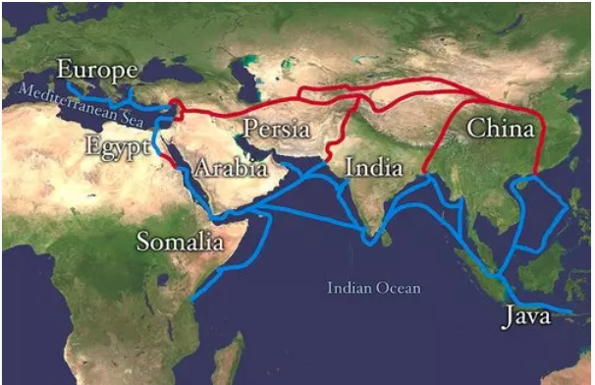
In the nineteenth century, a new type of traveler ventured onto the Silk Roads: archaeologists and geographers, enthusiastic explorers looking for adventure. Coming from France, England, Germany, Russia and Japan, these researchers traversed the Taklamakan desert in western China, in what is now Xinjiang, to explore ancient sites along the Silk Roads, leading to many archaeological discoveries, numerous academic studies, and most of all, a renewed interest in the history of these routes.
Image Source
Today, many historic buildings and monuments still stand, marking the passage of the Silk Roads through caravanserais, ports and cities. However, the long-standing and ongoing legacy of this remarkable network is reflected in the many distinct but interconnected cultures, languages, customs and religions that have developed over millennia along these routes. The passage of merchants and travelers of many different nationalities resulted not only in commercial exchange but in a continuous and widespread process of cultural interaction. As such, from their early, exploratory origins, the Silk Roads developed to become a driving force in the formation of diverse societies across Eurasia and far beyond.
The Silk Road was an ancient network of trade routes, formally established during the Han Dynasty of China, which linked the regions of the ancient world in commerce between 130 BCE-1453 CE. As the Silk Road was not a single thoroughfare from east to west, the term 'Silk Routes’ has become increasingly favored by historians, though 'Silk Road’ is the more common and recognized name.
The European explorer Marco Polo (1254-1324 CE) traveled on these routes and described them in depth in his famous work but he is not credited with naming them. Both terms for this network of roads were coined by the German geographer and traveler, Ferdinand von Richthofen in 1877 CE, who designated them 'Seidenstrasse’ (silk road) or 'Seidenstrassen’ (silk routes). Polo, and later von Richthofen, make mention of the goods which were transported back and forth on the Silk Road. The network was used regularly from 130 BCE, when the Han officially opened trade with the west, to 1453 CE, when the Ottoman Empire boycotted trade with the west and closed the routes. By this time, Europeans had become used to the goods from the east and, when the Silk Road closed, merchants needed to find new trade routes to meet the demand for these goods.
Goods transported through the Silk Road
From West to East | From East to West
- Horses  - Saddles and Riding Tack  - The grapevine and grapes  - Dogs and other animals both exotic and domestic  - Animal furs and skins  - Honey  - Fruits  - Glassware  - Woolen blankets, rugs, carpets  - Textiles (such as curtains)  - Gold and Silver  - Camels  - Slaves  - Weapons and armor | - Silk  - Tea  - Dyes  - Precious Stones  - China (plates, bowls, cups, vases)  - Porcelain  - Spices (such as cinnamon and ginger)  - Bronze and gold artifacts  - Medicine  - Perfumes  - Ivory  - Rice  - Paper  - Gunpowder

Interactive Silk Road Maps: World Map (https://worldmap.harvard.edu/maps/5079)

Students can interact with this Map and learn the Silk Road route more Visually.

References

Unesco Digital Library. (2002). The SIlk Roads Project: “Integral Study of the Silk Roads: Roads of Dialogue”. Retrieved from https://unesdoc.unesco.org/ark:/48223/pf0000159189

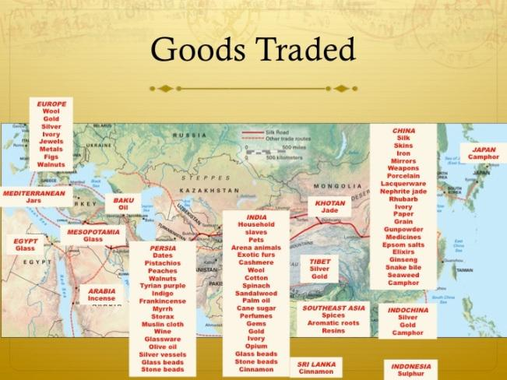
Image Source
Teacher Guidance
Activating students’ prior knowledge
Provide students a handout with new and complex terms (see Handout 1: Glossary Terms, pg. 8). Pair them up in groups of 2, and let them define the words. If they come across a word that they have not seen before, they can write ‘new word’ instead of defining it.
Teacher will then ask each group to share their definitions and list the new words stated by each group on the white/black board. Teachers will then share the definition of each word and state that these terms will support them in learning about the Silk Road and Globalization.
Address any misconceptions on the topic or term immediately.
Learning Activities
*Note to teacher: The time breakdown is provided as a rough estimate. Please change the times to meet your classroom needs. They can also be divided across multiple days
Topic | Student Activity | Teacher Guidance
What is the Silk Road?  <15 minutes> | Students will actively engage in discussions and activities.  Students will complete Handout 1: Glossary Terms, pg. 8. | Teacher will review the learning goals for the day.  Teachers can begin by asking questions about the Silk Road to activate students' background knowledge. Provide background information on the Silk Road. This can include viewing the Silk road map, routes, or glossary sharing.  Teachers will ask students to share the glossary terms meanings and provide the meaning for terms that are incorrect or not known by the students.
Goods and Services Traded via Silk Road  <30 minutes> | In groups of 2 or 3, students will put on their researcher hats. They will be assigned an Ipad, desktop, or any technology available in the school, to research the questions -  - How did trade take place (modes of transportation, currency, etc)?  - Apart from the trade of goods, what else was transferred via silk road (art, religion, diseases language, etc)?  (Students are encouraged to look at current events while answering this question) | This activity is to promote students’ critical thinking process and ability to put forth their thoughts during a discussion. The activity is also designed to help students understand how the transportation system has evolved and relate to more current events like spread of diseases, availability of international shipping, etc.  Since it is a student-led discussion, the teacher will play the role of a facilitator. Teachers can share/clarify ideas where appropriate while making sure the discussion stays on track.  “Crash Course” Silk Road Videos  - Early Silk Road (https://www.youtube.com/watch?v=lLeIclx2lAU)  - The Silk Road: Connecting the ancient world through trade (https://www.youtube.com/watch?v=vn3e37VWc0k)  - A great TedTalk to show to students in class or as a take home assignment.  - Silk Road Trade Goods (https://www.youtube.com/watch?v=8VEVZJ6-4JQ)
The New Silk Road  <20 minutes> | Students will watch the documentary on ‘The New Silk Road’  https://www.channelnewsasia.com/news/video-on-demand/new-silk-road  (See Handout: Handout 2: Watch the Video and Answer the following questions, pg. 9 to 11)  After watching the video and answering the questions Students will summarize what they learned in each group to the whole class.  Take home assignment  Answer the questions-  - Draw the New Silk Road Route (see Handout 3, pg. 13)  - How is it different from the Old Silk Road?  - What are the major goods and services traded? | Teachers will divide students into groups for the documentary activity.  Teachers will provide instructions that each group will watch the time-stamps mentioned on their worksheet and answer the questions.  Teacher will collect the handouts at the end and grade the worksheets.  Teacher will distribute the Take home assignment handout see Handout 3, pg. 13) and clarify any questions they may have.  “Crash Course” on New Silk Road Videos  - The New Silk road https://storymaps.esri.com/stories/2018/silk-road/index.html  - Book: The New Silk Road https://www.amazon.com/New-Silk-Roads-Present-Future/dp/1526607425
Globalization  <20 minutes> | Student Activity  Think-Pair-Share  - Students are grouped to research the goods that are available in the USA as a result of the New Silk Road.  - Each group will share their findings and discuss-  ‘How has the global economy shaped the USA?’. | Teachers will define and extend the knowledge on globalization. Teachers will focus on connecting prior knowledge and share new information.  Resources to help teachers understand Globalization:  - What is Globalization? How has the global economy shaped the USA?  https://www.piie.com/microsites/globalization/what-is-globalization  - The Silk Road and its impact on globalization  (https://www.casa-arts.org/cms/lib/PA01925203/Centricity/Domain/54/the-silk-road-and-globalization.pdf)  - The New Silk Road, Old Concepts of Globalization, and New Questions  (https://www.researchgate.net/publication/321260954_The_New_Silk_Road_Old_Concepts_of_Globalization_and_New_Questions)
Debrief/ Reflect | Students will ask any questions and clarify any confusion or misconception.  Exit Ticket:  - What is one valuable thing you learned in this topic?  - In your opinion, is Globalization a boon or a curse? Explain. | Teachers will clarify students’ confusions or misconceptions.

HANDOUT

Handout 1: Glossary Terms

Term | Definition
Silk Road
Trade Route
Caravan
Trade
Topographic Map
Plateau
Barter
Mirage
Oasis
Network
Toga
Animal Husbandry

HANDOUT

Handout 2: Watch the Video and Answer the following questions
‘The New Silk Road’- https://www.channelnewsasia.com/news/video-on-demand/new-silk-road

Watch the documentary and answer the below questions. Each group has a time stamp, make sure to adjust the video accordingly before you begin to watch.

Group 1: China & Russia: Allies in a Contested World (Time: 1:50 to 12:30)

- What is known as China’s key economic corridor? ______________________________
- What are the 2 main fields Beijing and Moscow work together in?
A.__________________________ & B. ________________________________
- What Goods and Services are China providing Russia in exchange for their valuable resources? _____________________________________________________________

- What contribution from Beijing put a smile on President Putin’s face? ______________________________________________________________________

- What are the challenges encountered by the Moscow Zoo in taking care of the Pandas?
__________________________________________________________________________________________________________________________________________________________________________________________________________________

- What sparked an outcry following the Pandas arrival in Denmark? Explain.
____________________________________________________________________________________________________________________________________________
____________________________________________________________________________________________________________________________________________

- How is the China-Russia Business Park different from other industrial parks?
______________________________________________________________________
____________________________________________________________________________________________________________________________________________

Group 2: China & Russia: Allies in a Contested World (Time: 12:38 to 23:50)
- What is the specialized kind of sight-seeing the Chinese explore Russia called? What is its significance?
______________________________________________________________________
____________________________________________________________________________________________________________________________________________
- What is the Museum dedicated to in the ‘Red tour’ route?
______________________________________________________________________
____________________________________________________________________________________________________________________________________________
- Why has Russia taken China’s side in the history of the Trade war?
______________________________________________________________________
____________________________________________________________________________________________________________________________________________
- Why was China forced to look for alternative sources of meat? Who filled the gap?
______________________________________________________________________
____________________________________________________________________________________________________________________________________________
- How many tons of chicken is Russia exporting to China every month?
______________________________________________________________________
____________________________________________________________________________________________________________________________________________
- According to Adrey Dalvov, the Chief Analytics Officer, will the demand for meat decrease once the Swine Flu subsides? Why or why not?
______________________________________________________________________
____________________________________________________________________________________________________________________________________________
______________________________________________________________________

- Which company joined hands with Russia after the Trade War with the United States & its Allies over the allegation of espionage?
____________________________________________________________________________________________________________________________________________
______________________________________________________________________
- If the United States relaxes its pressure on China, would it affect Russia/China’s collaboration with each other? Explain.
____________________________________________________________________________________________________________________________________________
______________________________________________________________________

Group 3: Tula: Russia’s Armament Hub & Ukrainian Crisis, 2014 (Time: 12:57 to 33:00)

- What is Tula known for? _________________________________________________

- What other alternative opportunities is Tula looking for? Describe.
____________________________________________________________________________________________________________________________________________
______________________________________________________________________

- Which country is setting up their first car manufacturing unit in Tula?
______________________________________________________________________

- What are some of the incentives given to the manufacturing company by Russia?
____________________________________________________________________________________________________________________________________________
______________________________________________________________________

- How does the unit help improve Tula’s residents' lives? Why or why not?
____________________________________________________________________________________________________________________________________________
______________________________________________________________________

- Why were the Americans and Europeans unimpressed with China?
____________________________________________________________________________________________________________________________________________
______________________________________________________________________

- What did China gain in return from Russia?
____________________________________________________________________________________________________________________________________________
______________________________________________________________________

- How did the integration help the Russian economy export to the global market?
____________________________________________________________________________________________________________________________________________
______________________________________________________________________

- Why does China support Russia to build an ‘Arctic/Polar Silk Road’?
____________________________________________________________________________________________________________________________________________
______________________________________________________________________

HANDOUT
Handout 3: Trace the Silk Road Route

- Draw the New Silk Road Trade Map.
- Name the goods traded in each identified region.
- Name the mode of transportation in different regions.

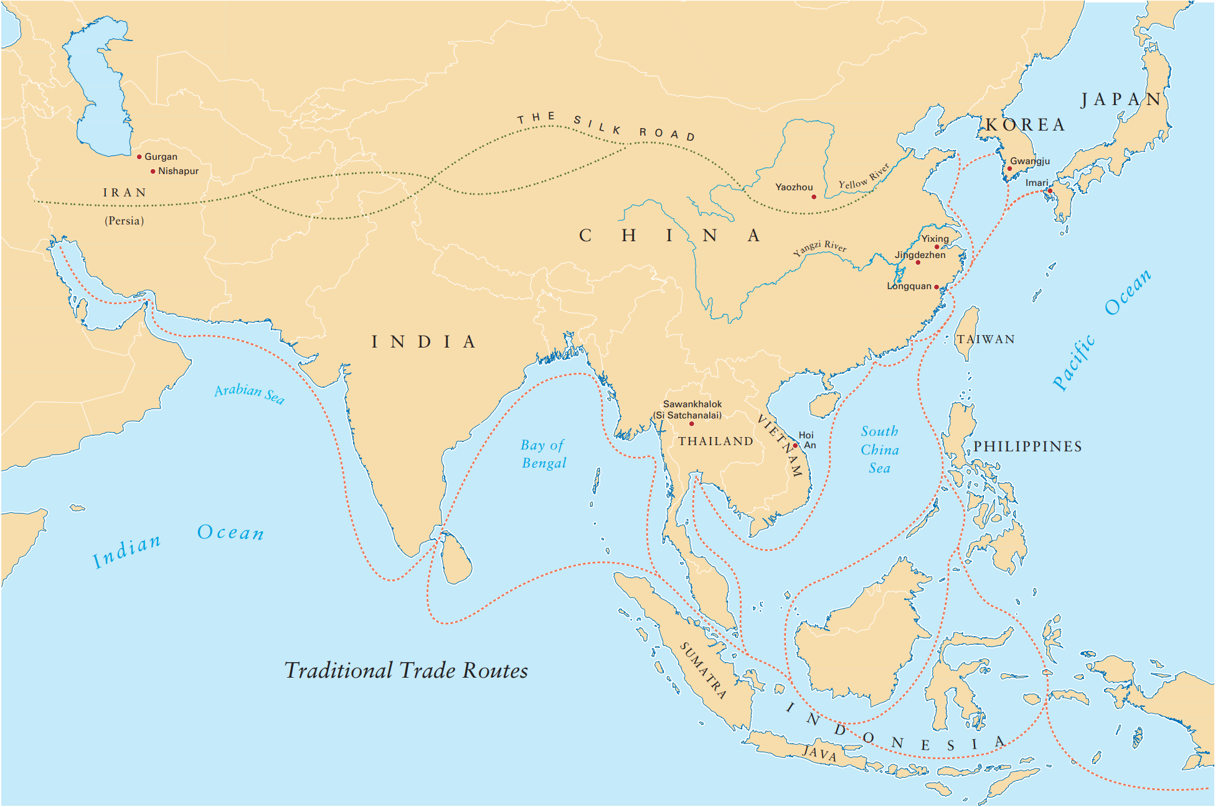

HANDOUT
Handout 4: Chinese Inventions
Students will identify chinese inventions and complete the table as seen in the example below.
Pro Tips: Teachers can also encourage students to draw these inventions on a separate sheet of paper. Every class has one or two (maybe more) good artists and they seem to retain information by drawing – this also helps the other students because they usually appreciate their classmates’ artistic skills.

Invention | History | Purpose | Today’s Use
For Example:  Paper & printing | the first paper was made from bamboo that was ground into a pulp then pressed into paper (in ancient times it took 100 days) printing began around 1000 AD with wood cuttings, to movable type | precise record-keeping of everything! printing large quantities of text more quickly – the thousands of characters in Chinese language limited use of movable type for them, but really spread in Europe | Think about the massive consequences – books for the masses, education, history, printed money – so much!

HANDOUT
Handout 5: The Ancient Silk Road

Directions: Using the reading, answer the following questions.
The Silk Road was not actually a road. It was not paved. It was not even a single route. The Silk Road was a name given to any route that led across China to Rome. It was a 4000-mile trip. At one end was China. At the other end was Rome. Each had something the other wanted. Rome had gold and silver and precious gems. China had silk, porcelain, spices and ivory. Ideas also traveled along the Silk Road, ideas that affected everyone.

The Romans were not surprised to hear of another great civilization hidden over the mountains. They had been looking for “the Silk People” for a long time. The Romans discovered pieces of silk from some of the people they conquered. Silk quickly became popular in Rome. But it was scarce. The Romans wanted more silk. But they did not know who was making this wonderful material.

The Romans tried to find the traders as they came into the towns and villages. But the traders hid from the Roman soldiers. They knew they had nothing to tell them. They did not know who was making the silk. They only traded for the silk. They traveled a short way along the silk road and traded with the people they found.

In frustration, the Romans sent out parties of soldiers to follow the Silk Road, and find the source, the people who were making the silk. Most of the soldiers never returned. Those who did reported they could not find a way through the desert. They had to turn back.
It was incredibly dangerous to travel along the Silk Road. You faced desolate white-hot sand dunes in the desert, forbidding mountains, brutal winds, and poisonous snakes. There was one nice section, called the Gansu Corridor, a relatively fertile strip that ran along the base of one of the mountains. To reach this strip, you had to cross the desert or the mountains. And of course, there were always bandits and pirates.

Even the traders did not make the whole trip. They worked in relays. Each trader would go a certain distance, exchange their goods for other goods, and hopefully return. The next would move along the road, trade, and hopefully return.

There were three main routes, and all were dangerous.
• Northern Route – Westward to Black Sea
• Central Route – Westward to Persia, Mediterranean Sea, Rome
• Southern Route – Westward to Iran, India
The Silk Road took caravans to the farthest extent of the Han Empire. Sections of the Great Wall were built along the northern side of the Gansu Corridor to try and prevent bandits from the north from harming the trade. Over the centuries, the Silk Road developed a civilization of its own. Where possible, the Silk Road became lined with huge temples and booming cities. It became far easier to travel the road. But it was never easy. There were still vast stretches of deserts and mountains to cross, with no city or water in sight.

- What goods flowed into China along the Silk road?

- How did the Romans discover the Silk Road?

- Why was the journey along the Silk Road difficult? What geographic features added to the difficulty?

- Why were merchants able to make a profit on the Silk Road?

- Which city is the easternmost and westernmost cities on the Silk Road?

- Do you think that trade between countries today leads to exchange of technology and ideas? Explain.

Appendix A: Images Related to Silk Road

Map of the Silk Road
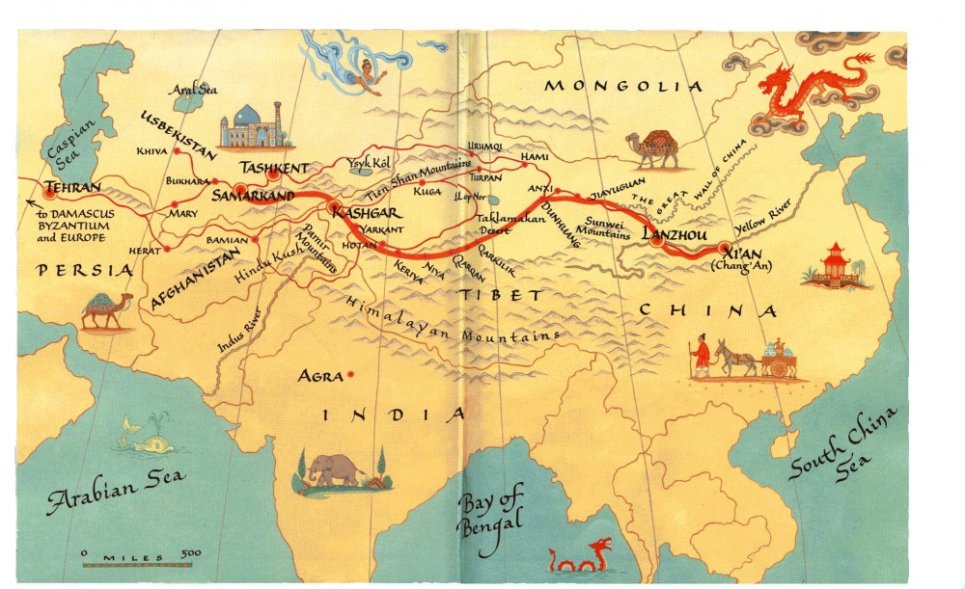
. Image Source

Painting of Women from the Song Dynasty inspecting a bolt of Silk.
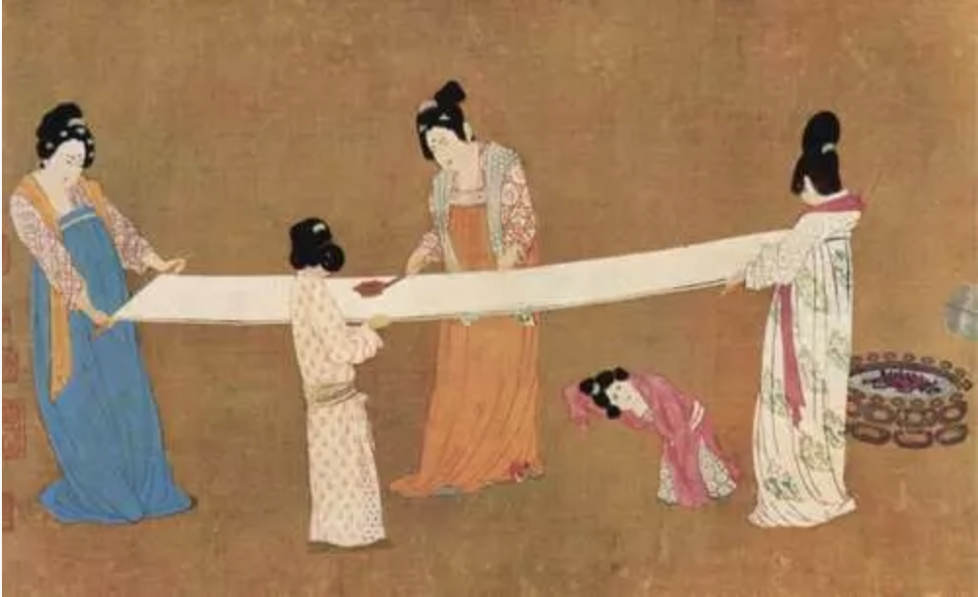
Image Source.

Some Goods Traded on The Silk Road
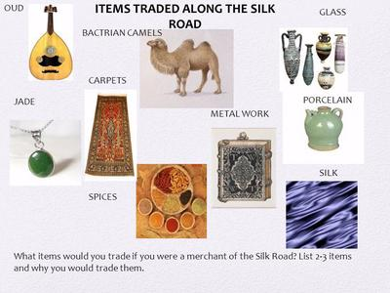
Image Source.

Appendix B: Resources for Teachers

- Teacher training workshop PowerPoint
  - Empires, Silk Roads, and the Dissemination of Ancient Chinese Technology By Dr. Ting Zhang (https://cpb-us-e1.wpmucdn.com/blogs.gwu.edu/dist/6/2325/files/2019/09/DCPS-Publication.pdf)

- Maps of Silk Road
  - Interactive maps
    - World Map (https://worldmap.harvard.edu/maps/5079)
    - Cities along the Silk Road (https://en.unesco.org/silkroad/network-silk-road-cities-map-app/en)
    - Interactive Silk Road Map Exercise (https://depts.washington.edu/silkroad/maps/mapquiz/mapquiz.html)
  - 1st to 3rd Century Map (http://afe.easia.columbia.edu/special/imgs/silkroad_map1.pdf)
  - 7th to 9th Century Map (http://afe.easia.columbia.edu/special/imgs/silkroad_map1.pdf)
  - 13th to 14th Century Map
(http://afe.easia.columbia.edu/special/imgs/silkroad_map4.pdf)
  - 15th Century Map
(http://afe.easia.columbia.edu/special/imgs/silkroad_map5.pdf)

- Books
  - A New History of the World By Peter Frankopan

Religions of the Silk Road: Premodern Patterns of Globalization by Richard Foltz

The Global Silk Road: Globalization, Islam and the Creation and Distribution of Knowledge Using the Internet by Brian Hilton, CHong Ju Choi, and Carla Millar

- Video Resources
  - Early Silk Road
(https://www.youtube.com/watch?v=lLeIclx2lAU)
  - The Silk Road: Connecting the ancient world through trade
(https://www.youtube.com/watch?v=vn3e37VWc0k)
  - How The Ancient Silk Road Pioneered Globalization
(https://www.youtube.com/watch?v=cHSgkZsCgtw)
  - Silk Road Trade Goods
(https://www.youtube.com/watch?v=8VEVZJ6-4JQ)

- Articles
  - Silk Road: A Glance at Archaic Globalization
(https://iwp.uiowa.edu/silkroutes/city/kolkata/text/silk-road-glance-archaic-globalization)
  - Geography Along the Silk Road
(http://www.chinainstitute.cieducationportal.org/cimain/wp-content/themes/chinainstitute/pdfs/education/fromsilktooil_pdf3.pdf)
  - Ethnic Relations and Political History Along The Silk Roads
(http://www.chinainstitute.cieducationportal.org/cimain/wp-content/themes/chinainstitute/pdfs/education/fromsilktooil_pdf4.pdf)
  - Exchange of Goods and Ideas Along The Silk Roads
(http://www.chinainstitute.cieducationportal.org/cimain/wp-content/themes/chinainstitute/pdfs/education/fromsilktooil_pdf5.pdf)
  - Religions Along the Silk Road
(http://www.chinainstitute.cieducationportal.org/cimain/wp-content/themes/chinainstitute/pdfs/education/fromsilktooil_pdf6.pdf)
  - Art Along the Silk Road
(http://www.chinainstitute.cieducationportal.org/cimain/wp-content/themes/chinainstitute/pdfs/education/fromsilktooil_pdf7.pdf)
  - The Silk Roads: Globalization before neoliberalization: Introduction to the special issue
(https://journals.sagepub.com/doi/full/10.1177/2057891118793735)
  - The history of Supply Chain From the Silk Road to Globalization
(https://medium.com/@marcellvollmer/the-history-of-supply-chain-from-the-silk-road-to-globalization-845e6e4733ce)
  - The Silk Road and its impact on globalization
(https://www.casa-arts.org/cms/lib/PA01925203/Centricity/Domain/54/the-silk-road-and-globalization.pdf)
  - The New Silk Road, Old Concepts of Globalization, and New Questions
(https://www.researchgate.net/publication/321260954_The_New_Silk_Road_Old_Concepts_of_Globalization_and_New_Questions)

Appendix C: Content Standards
DCPS Standards
The World in Spatial Terms
- 6.1. Students use maps, globes, atlases, other technologies and process information about people, places,and environments.
- 6.2. Students acquire a framework for thinking geographically, including the location and unique characteristics of places.
- 7.11. Summarize the development of Chinese cultural, economic, political, and social institutions and China’s influence on other developing civilizations.
- Describe the foreign trade through the Silk Roads and the sea. (G, E)

FCPS World History & Geography: 1500 A.D. to Present Standards of Learning
STANDARD WHII.2d
The student will apply social science skills to understand the political, cultural, geographic, and economic conditions in the world about 1500 A.D. (C.E.) by
d) analyzing major trade patterns;
Essential Understandings-
By 1500 A.D. (C.E.), regional trade patterns had developed that linked Africa, the Middle East, Asia, and Europe.-
Essential Knowledge
Silk Road across Asia to the Mediterranean Basin
Importance of trade patterns
Exchange of products and ideas

STANDARD WHII.2e
The student will apply social science skills to understand the political, cultural, geographic, and economic conditions in the world about 1500 A.D. (C.E.) by
e) citing major technological and scientific exchanges in the Eastern Hemisphere.
Essential Understandings
By 1500 A.D. (C.E.), technological and scientific advancements had been exchanged among cultures of the world.-
Essential Knowledge
Products exchanged along trade routes
Paper, compasses, silk, porcelain (China)
Textiles (India and the Middle East)
Ideas exchanged along trade routes
Numeral system (India and the Middle East)
Scientific knowledge—medicine, astronomy, mathematics

