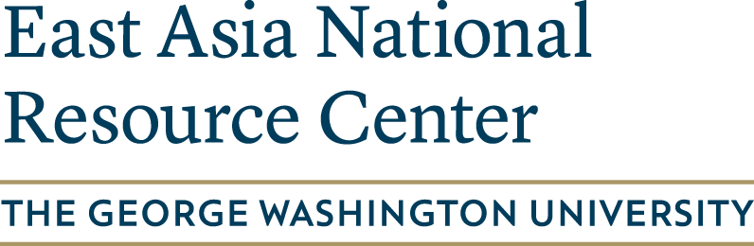
K-12 East Asian Studies
Advisory Council:
Call for Applications

K-12 educators with specializations or interests in East Asian languages, history, and culture are invited to apply to the inaugural K-12 East Asian Studies Advisory Council at the George Washington University East Asia National Resource Center. Advisory Council members will collaborate with NRC staff on developing curriculum materials and workshops and will receive an honorarium of $1000.

Please submit your completed application to lisa.lackney@gwu.edu.

Application

First Name: ________________________ Last Name: _________________________________

Home Address: ______________________________________________

City: ______________ State: _____ZIP: __________________

Phone Number: (___)___-______ Email: ______________________________

Current Institutional Affiliation

School Name: ____________________________________

School District: ___________________________________

Department: ______________________________________

School Address: ______________________________________________

City: ______________ State: _____ZIP: __________________

Phone Number: (___)___-______ Website: ______________________________

Current Teaching Assignments

Briefly describe any classes you teach or expect to teach that will use knowledge of East Asian languages, history, or culture.

Collaboration with the NRC

Briefly discuss your ideas for working with the NRC. Tell us about what kind of workshops or curriculum materials you would like to produce with NRC staff.

